** **

GCE/IAL applicable

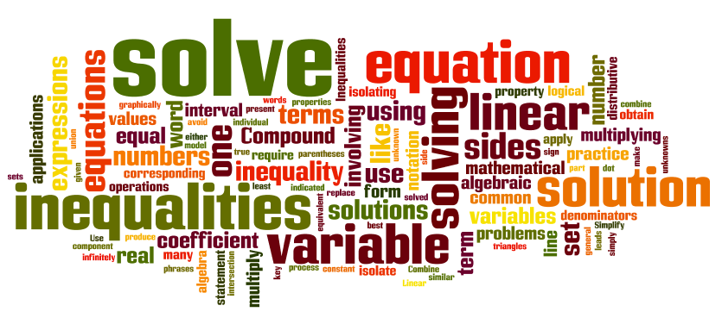

**Equations and inequalities**

**For C1(GCE)/C12(IAL)**

**Content**

|  |  |
| --- | --- |
| **Main Concept 1: Linear Equations with two unknowns** |  |
| **Elimination** |  |
| **Substitution** |  |
| **Main Concept 2: Solving quadratic inequalities** |  |
|  |  |

**Introduction:**

There are two parts in this booklet: equations and inequalities. The ability to solve a question is most important in this chapter.

For equations, most of them are equations with two unknowns, visualization is used to present the ideas.

For inequalities, there is only one unknown x, but they could be quadratic inequalities, so please revise if you are not familiar with it.

**Main Concept 1: Linear Equations with two unknowns**

Notes: The equation is still the same whatever coefficient you add to the equation. For example, $2x+3y=6 and 4x+6y=12$, they represent the same equation of straight line.

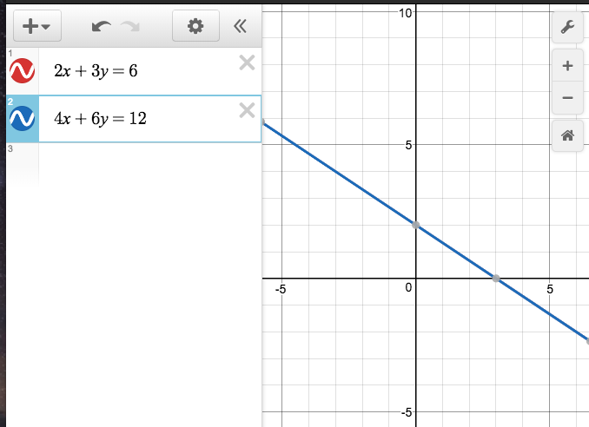 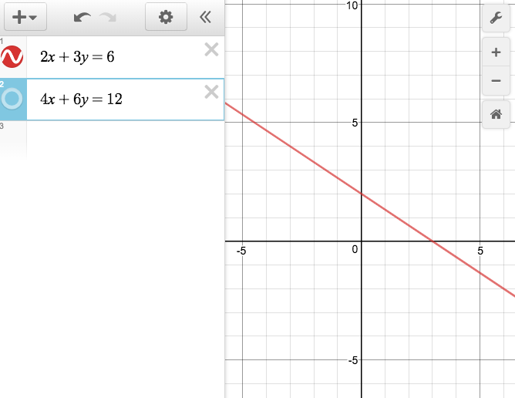

It is important to introduce this idea because it is closely related to our following idea. Solve equation by elimination.

Solve equation by elimination

Given two linear equations with two unknowns.

$$ax+by=c$$

$$dx+ey=f$$

We could try to multiply them to

$$adx+bdy=cd$$

$$adx+aey=af$$

Then we could subtract equation 1 to equation 2, so there will be only one unknown y is left, the value of y is solved, and put it into one of the equations to solve x.

For example, $2x+3y=12$

$7x+5y=35$

X7 and X2 then we have

$14x+21y=84$

$14x+10y=70$

$-$ and we get $11y=14$

$y=\frac{14}{11}$, and put it into equation , we get $x=\frac{45}{11}$.

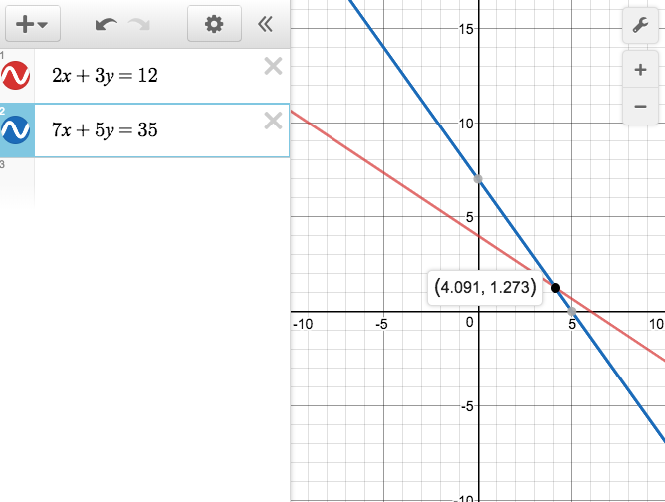

**Exercise 1**

$x+y=3$

$$2x+3y=0$$

$5x+6y=9$

$$2x+3=4y$$

$5x+4y=20$

$$3x-2y=12$$

$4 x-10y=4$

$$2x+3y=12$$

$12x-15y=12$

$$12x+4y=50$$

$2x-y=1$

$$4x+2y=-30$$

$x+2y=3$

$$4x-y=6$$

$x+y=3$

$$2x+3y=5$$

Another method is substitution.

The first step is to make one unknown on one side, and the other one is on the other side, or we call it express one unknown with another one.

For example,

$x+2y=3$,

$$x^{2}+3xy=10$$

Step 1: make x or y as subject, here we choose y, $3-x=2y$.

Step 2: put the new expression into the other equation.

Then

$x^{2}+\frac{3x(3-x)}{2}=10$

$${2x}^{2}+3x\left(3-x\right)=20$$

$$x^{2}-9x+20=0$$

Solving quadratic equations and we get x=5 and 4, put them into the equations and find their respective y, they are $-1 and \frac{-1}{2}$.

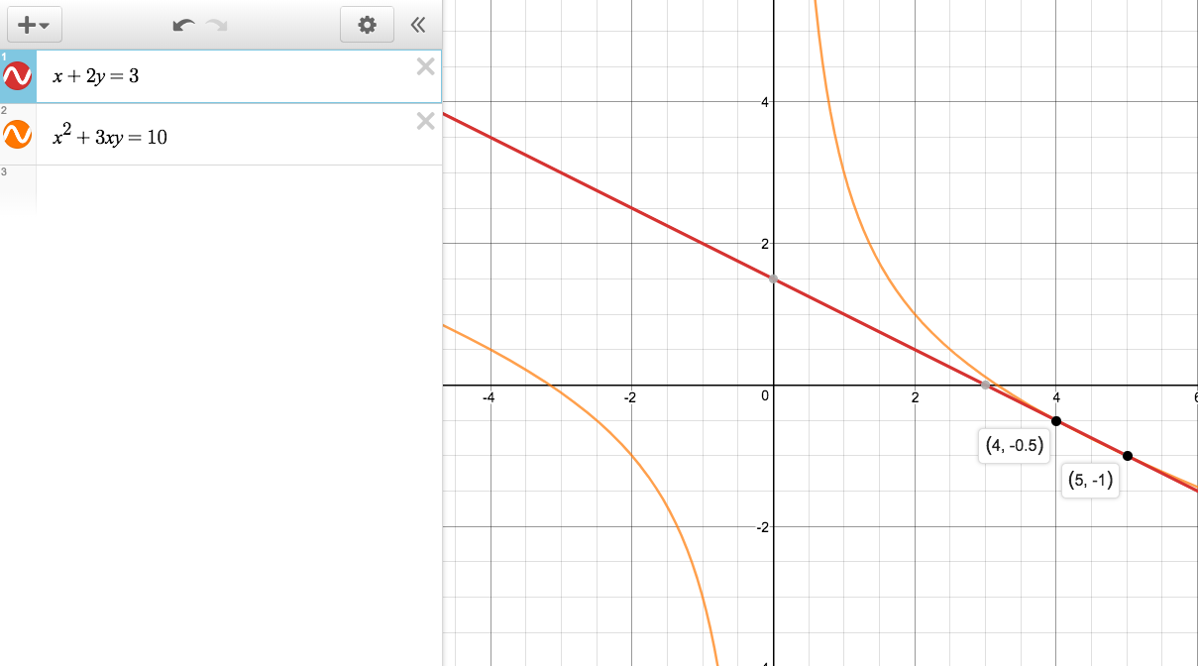

Using substitution, we can solve different types of equations’ intersections like inverse equations, equations of circles, parabola, and hyperbola equations on the Cartesian plane.

**Exercise 2**

$x+y=3$

$$2x+3y=5$$

$3x-2y=1$

$$x^{2}+y^{2}=25$$

$x-2y=1$

$$3xy-y^{2}=8$$

$x+2y=3$

$$3x^{2}-2y-y^{2}=18$$

$x-2y=1$

$$3xy=6$$

$2x+2y=6$

$$3x^{2}-y^{2}=8$$

$2x+y=6$

$$3xy=8$$

$y=x-4$

$$y^{2}=2x^{2}-17$$

Inequalities: There are two types of them, linear and quadratic, unlike equations, they are talking about the ranges.

For linear inequalities, you could draw a vector line in the coordinate system to help you easier to understand it.

For example, when we solve

$$3x-5<x+8 and 5x>x-8$$

And we have solution $-2<x<6.5$.

The graphical representation is 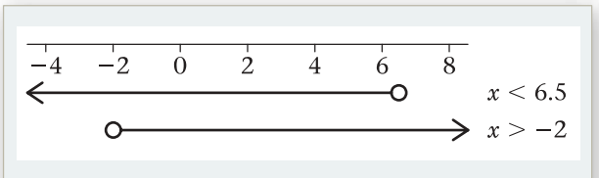

If the two lines do not have overlapping area, then there is no solution.

Please be aware of the colour of the circle, if it is black, that means the value itself is included in the solution, if it is white, that means the value itself is not included in the solution.

Please be aware of the statement itself. If the question requires an “or” answer then the bound is larger, if the question asks for an “and”, answer then the bound is smaller.

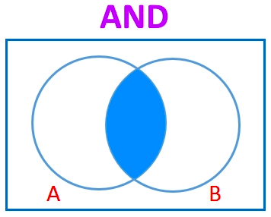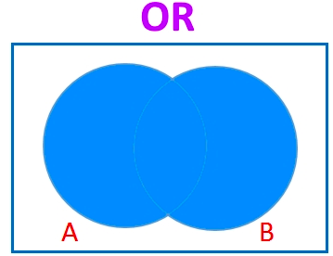

**Exercise 2 $.$**

1. $3\left(x-5\right)<7x$ and $3x-5<-9x+4$
2. $3\left(x-5\right)<7x$ and $3x-5<x-7$
3. $12\left(x-5\right)-24<7x$ and $6(3x-5)<12$
4. $3\left(x-5\right)<7x$ and $3x-5<x^{2}$

$1+x<25+3x$

$7x-7<7-7x$

$\left(x-5\right)<7x$

$12-2x<9$

$2\left(x-5\right)≥0$

$8\left(x-1\right)≥1-x$

$2\left(x-5\right)≥3(x-4)$

$x-2\left(x-5\right)≥45$

$-x\left(x-5\right)≥3+x-x^{2}$

**Main Concept 2: Solving quadratic inequalities**

There are some techniques that students can do.

Step 1: Group the like terms first.

Step 2: Make the highest order coefficient of x positive, and move the whole expression into that side, or multiply $-1$ and switch the symbol.

Step 3: Identify the symbol of the inequalities. If it is $<,≤$, then the solution is “and” type, if it is $>,≥$, then the solution is “or” type.

“And” type equation $ax^{2}-bx+c</≤0$

Graphical representation (as a mini-exercise)

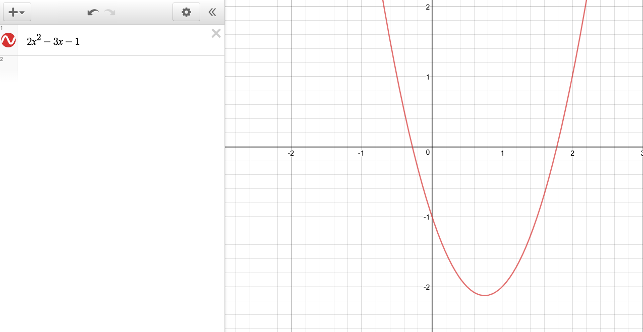

“Or” type equation $ax^{2}-bx+c>/≥0$

Graphical representation (as a mini-exercise)



**Exercise 2 $.$**

$3\left(x-5\right)x<7x$

$3\left(x-2\right)(x-6)<7x$

$12\left(x-5\right)-24<7x$

$3\left(x-5\right)x<7x$

$1+x<\left(25+3x\right)x$

$7x-7<\left(7-7x\right)x$

$\left(x-5\right)x<7x$

$12-2x<9x-x^{2}$

$2x\left(x-5\right)≥0$

$8\left(x-1\right)≥\left(1-x\right)x$

$2\left(x-5\right)≥3(x-4)(x+3)$

$x-2\left(x-5\right)≥45(x-3)x$

$-x\left(x-5\right)≥3+x-x^{2}$

$4(3x-5)<-\left(9x+4\right)x$

$3x-5<\left(x-7\right)x$

$3x-5<x^{2}$